Questions from the 2021 exam that i was a bit unsure of

Convolution / Convolve - Example
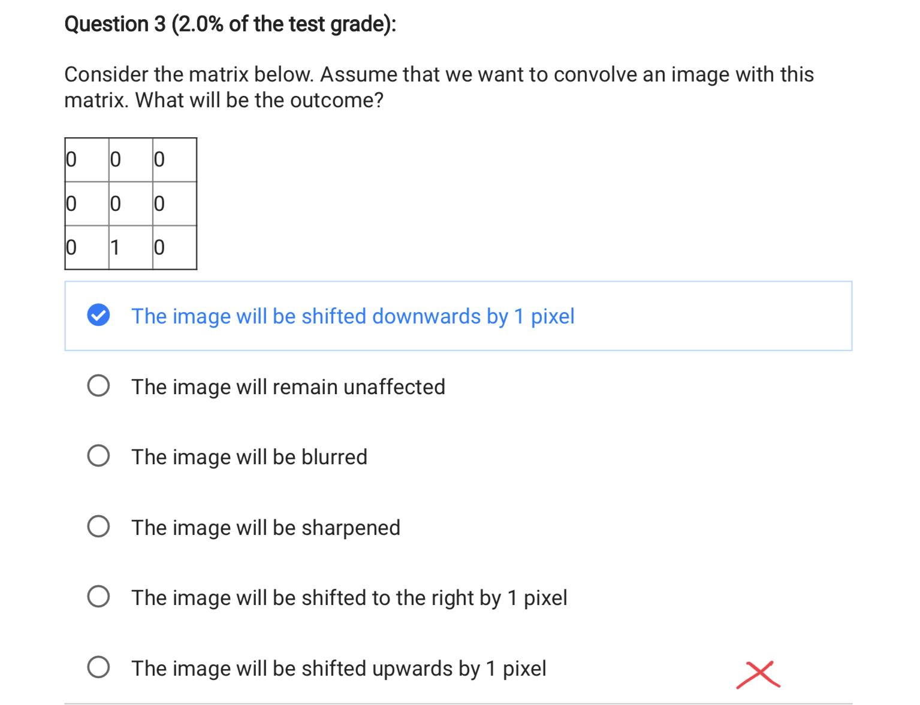
If the CONTENT moves downward, the IMAGE is said to be shifted UP.
The correct answer is “shifted upwards by 1 pixel.”
In convolution, the kernel is flipped 180° before use. The original kernel is:
0 0 0
0 0 0
0 1 0
After flipping, it becomes:
0 1 0
0 0 0
0 0 0
This places the 1 above the center, meaning each output pixel takes its value from the pixel above, producing an upward shift. If it were correlation (no flip), the shift would have been downward, but convolution always flips the kernel first.

Correlation / Convolution
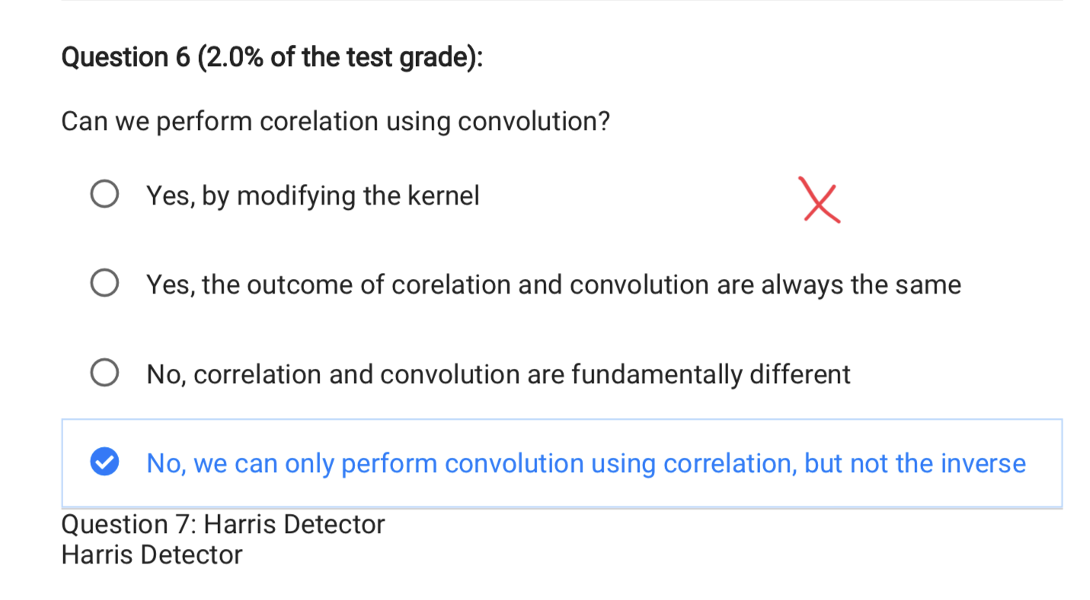
Yes, by modifying the kernel
Because:
Correlation = Convolution with the kernel flipped 180 degrees.
So if you flip the kernel before convolving, convolution produces exactly the same result as correlation.
The other statements are false:
• “Yes the outcome is always the same” → wrong, only true if the kernel is symmetric.
• “No, fundamentally different” → they are related by a flip, not fundamentally different.
• “No, only the inverse” → also wrong; convolution can simulate correlation, not the other way around.

Hough Transform
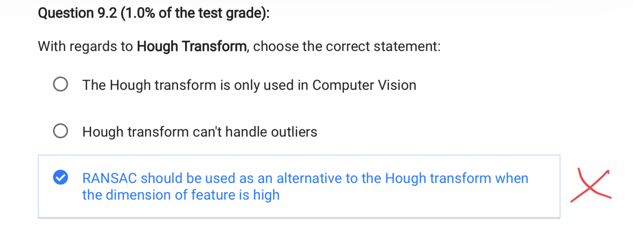

Option 1: “The Hough transform is only used in Computer Vision”
False.
Hough was originally used in particle physics.
It is widely used in robotics, medical imaging, pattern recognition, and many non-CV applications.

Option 2: “Hough transform can’t handle outliers”
False.
The Hough transform is explicitly designed to be robust to outliers because outliers scatter randomly in parameter space and do not vote consistently.
Only real inliers produce a strong peak in the accumulator.
Hough is very outlier-robust.

Option 3 (correct):
“RANSAC should be used as an alternative to the Hough transform when the dimension of the feature is high.”
Correct.
Why:
The Hough transform suffers from the curse of dimensionality.
If a model has many parameters (e.g., 4D, 5D, 8D models), the Hough accumulator becomes huge:
- More dimensions → exponentially more bins
- Memory explodes
- Computation explodes
- Peaks become harder to detect
RANSAC does not need an accumulator.
It works well even when the parameter space is high-dimensional because it just samples minimal subsets, fits a model, and counts inliers.
So:
- Low-dimensional models (lines, circles): Hough is efficient.
- High-dimensional models (homographies, fundamental matrices, 3D motion): RANSAC is far better.
This is why the third option is the only correct one.

Stero vision: Epipolar geometry
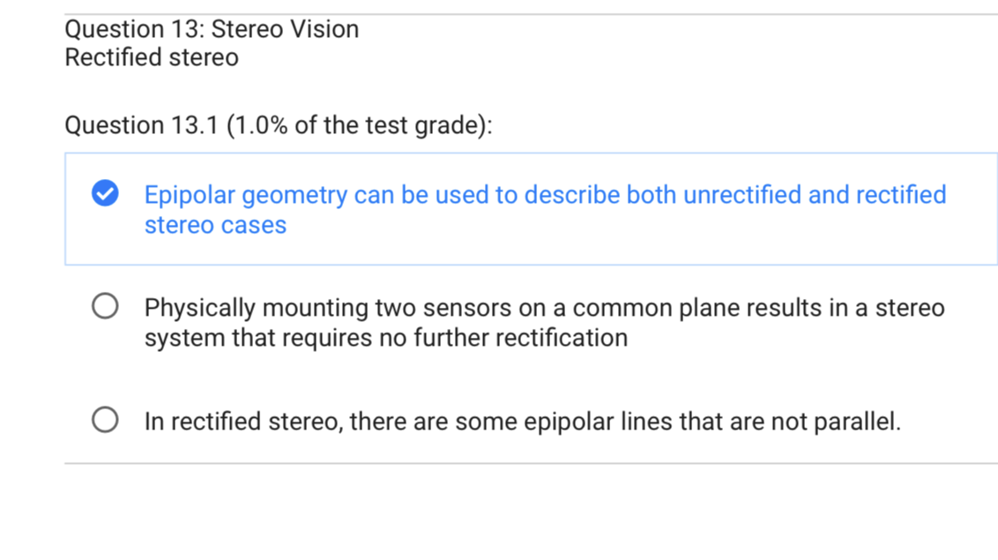
Correct statement:
Epipolar geometry applies to both unrectified and rectified stereo.
This is true because epipolar geometry always exists when two cameras view the same scene; rectification just simplifies it.
Incorrect statements:
• Physically mounting two sensors on a plane removes the need for rectification → false. Even small misalignments and lens distortions mean rectification is still required.
• In rectified stereo, some epipolar lines are not parallel → false. Rectification’s purpose is to make all epipolar lines perfectly horizontal and parallel.

Why do we need focal length and baseline
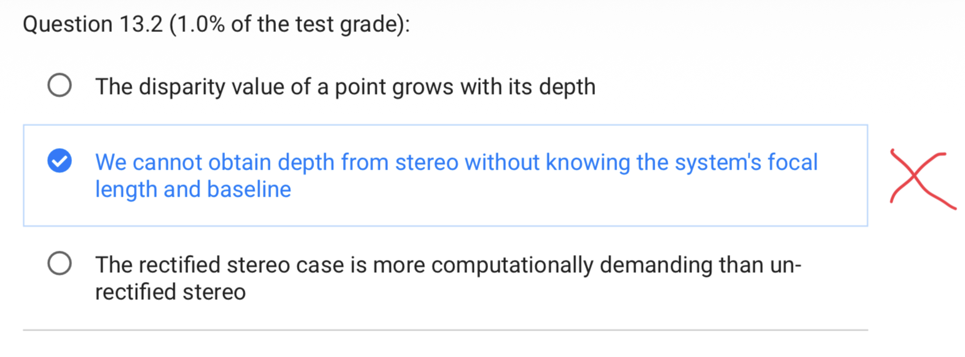

Why it is true
Stereo depth is computed using the formula:
Z = f · B / d
where
- Z = depth
- f = focal length
- B = baseline (distance between cameras)
- d = disparity (pixel shift)
Disparity alone tells you nothing about actual metric depth.
You only get a ratio between depths — not real-world measurements.
To compute real depth, you must know:
- Focal length → converts disparity (pixels) into an angle
- Baseline → gives the scale of the triangulation
Without f and B, the best you can say is:
“Point A is closer than point B.”
But you cannot compute how many meters away A or B actually are.
Therefore:
You need focal length and baseline to turn disparity into actual metric depth, so the statement is correct.

Dissimilarity Calculations in Stereo
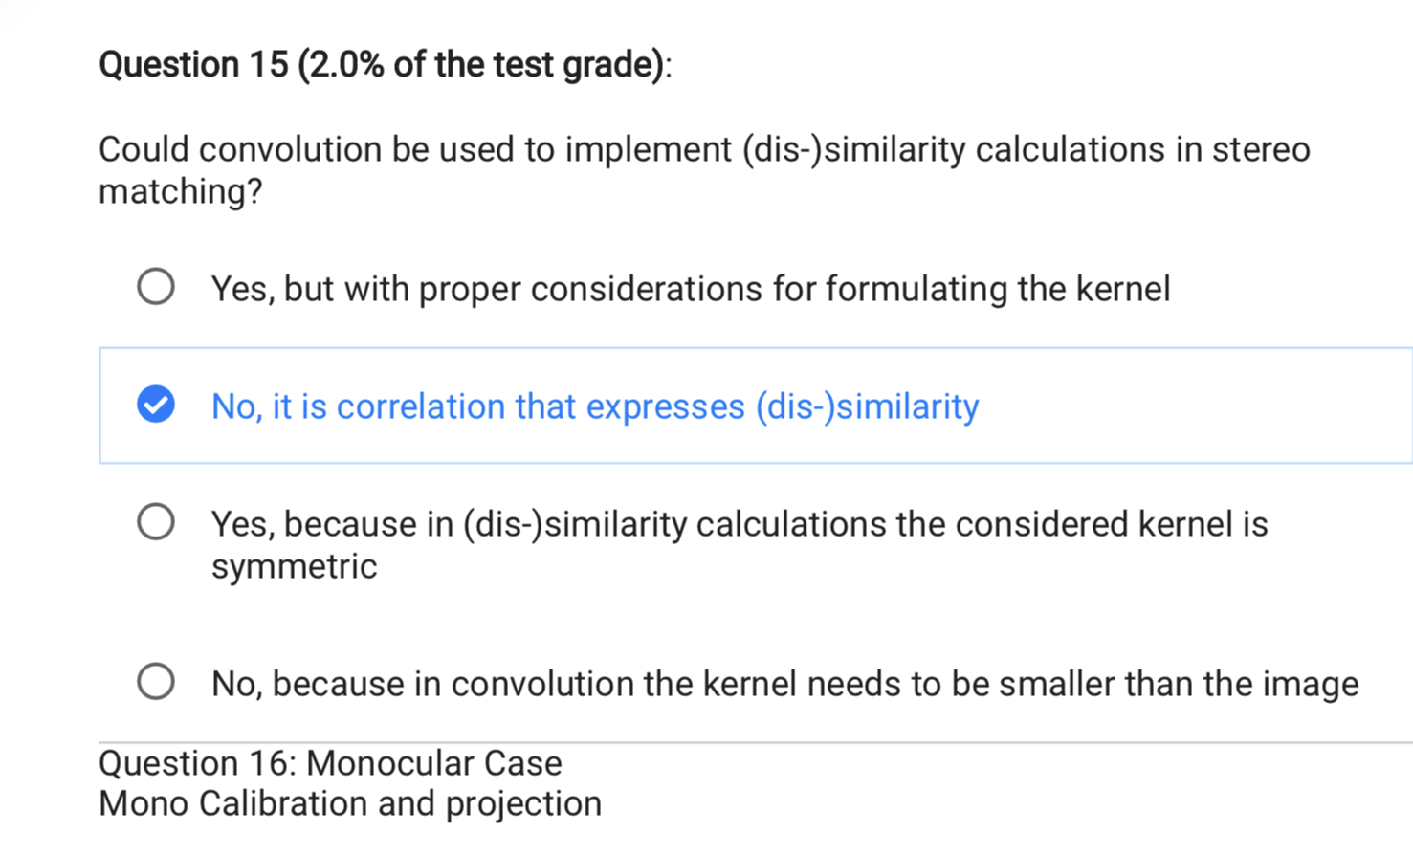
Correct answer
Yes, but with proper considerations for formulating the kernel

Why
Stereo matching uses correlation-like measures (SAD, SSD, NCC).
Correlation and convolution are basically the same operation except that convolution flips the kernel 180°.
Because this flip is trivial, convolution can implement any correlation-based similarity or dissimilarity measure used in stereo.
So the claim “No, only correlation expresses similarity” is false — convolution can do it too.

Why the others are wrong
• “Kernel is symmetric” → stereo kernels don’t need to be symmetric.
• “Kernel must be smaller than the image” → irrelevant and incorrect.
Convolution can compute the same similarity scores as correlation once the kernel is flipped; therefore the first option is correct.

Wrong question – Projection, calibration, Homography, projection
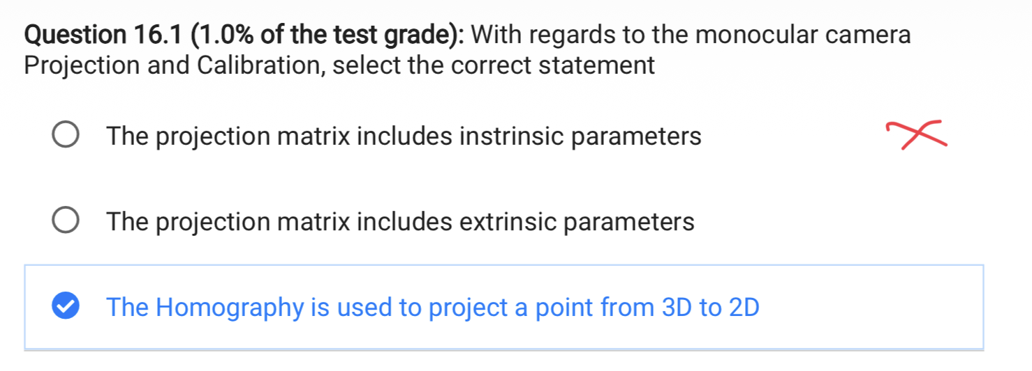
Top two are correct and bottom is wrong

Essential and Fundametal matrix
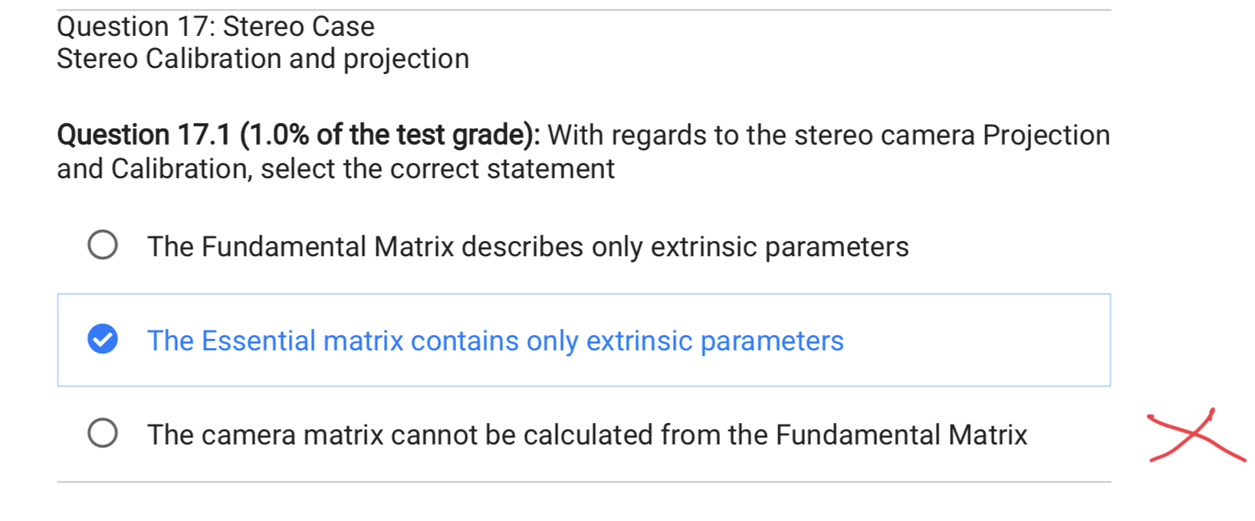
- Fundamental matrix (F): mixes intrinsic and extrinsic parameters, so you cannot recover the camera matrix (K) from (F).
- Essential matrix (E): after calibration, it reduces to ([t]_\times R), so it contains only extrinsic parameters, but this is not the correct choice in the question.
- The only universally correct statement is that the camera matrix cannot be calculated from the Fundamental Matrix, since (F) is defined for uncalibrated cameras and is intrinsically ambiguous.

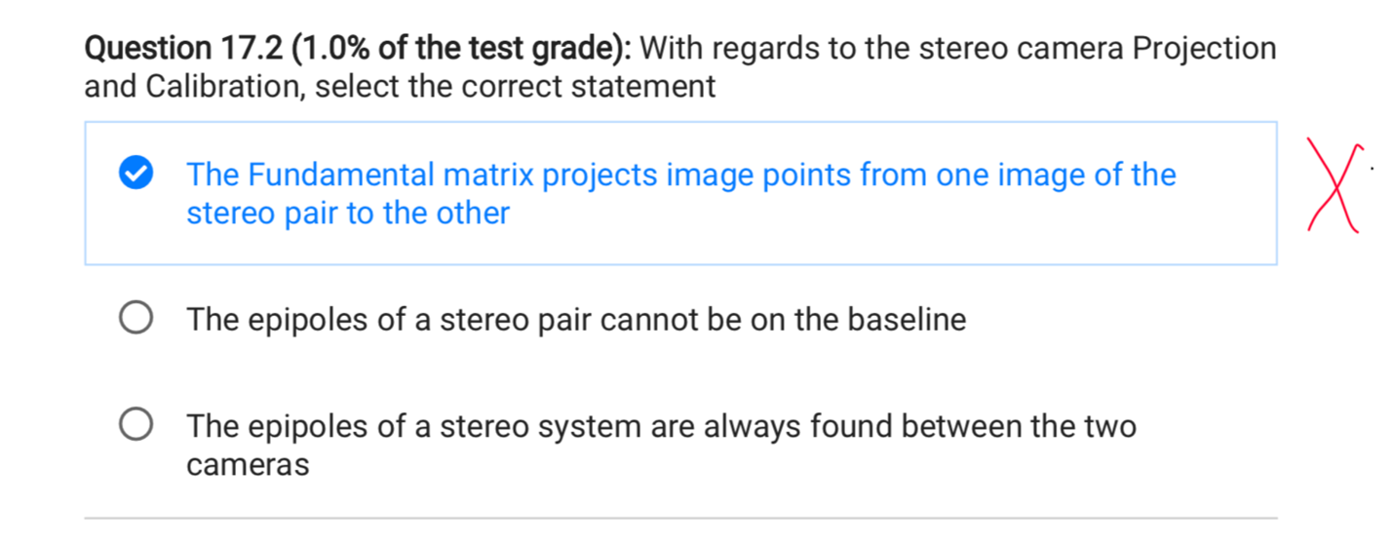

- The fundamental matrix does not project points from one image to the other; it only maps a point to an epipolar line, so the first statement is false.
- The epipoles are projections of the opposite camera center, so they can lie on the baseline projection; therefore the second statement is false.
- ✔️ Correct answer: “The epipoles of a stereo system are always found between the two cameras.”

Global alignment, local alignment, Kabsch
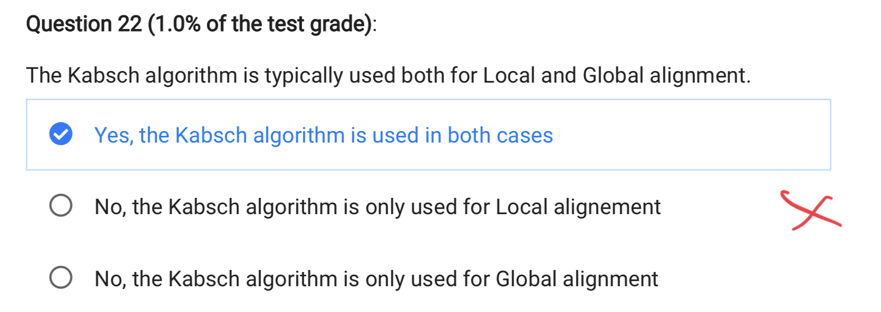
✅ Correct statement:
“No, the Kabsch algorithm is only used for Local alignment.”
Why this is correct:
- The Kabsch algorithm requires known point correspondences between two sets.
- This makes it suitable only for local alignment, where the relationship between points is already established.
- It computes the optimal rotation (and translation) that aligns these corresponding points.

❌ Incorrect statement:
“Yes, the Kabsch algorithm is used in both cases.”
Why it is incorrect:
- Global alignment involves finding correspondences and computing the transformation.
- Kabsch cannot find correspondences; it only refines a transformation after correspondences are known.
- Therefore, it cannot solve global alignment on its own.

❌ Incorrect statement:
“No, the Kabsch algorithm is only used for Global alignment.”
Why it is incorrect:
- Global alignment algorithms must search the entire space for a consistent match, often handling noise, outliers, and symmetries.
- Kabsch cannot perform this search and is not designed for global matching.
- It is strictly a local alignment method.

📌 Exam takeaway:
Kabsch = local alignment only → requires known correspondences → not usable for global alignment.

Kalman filter state estimation
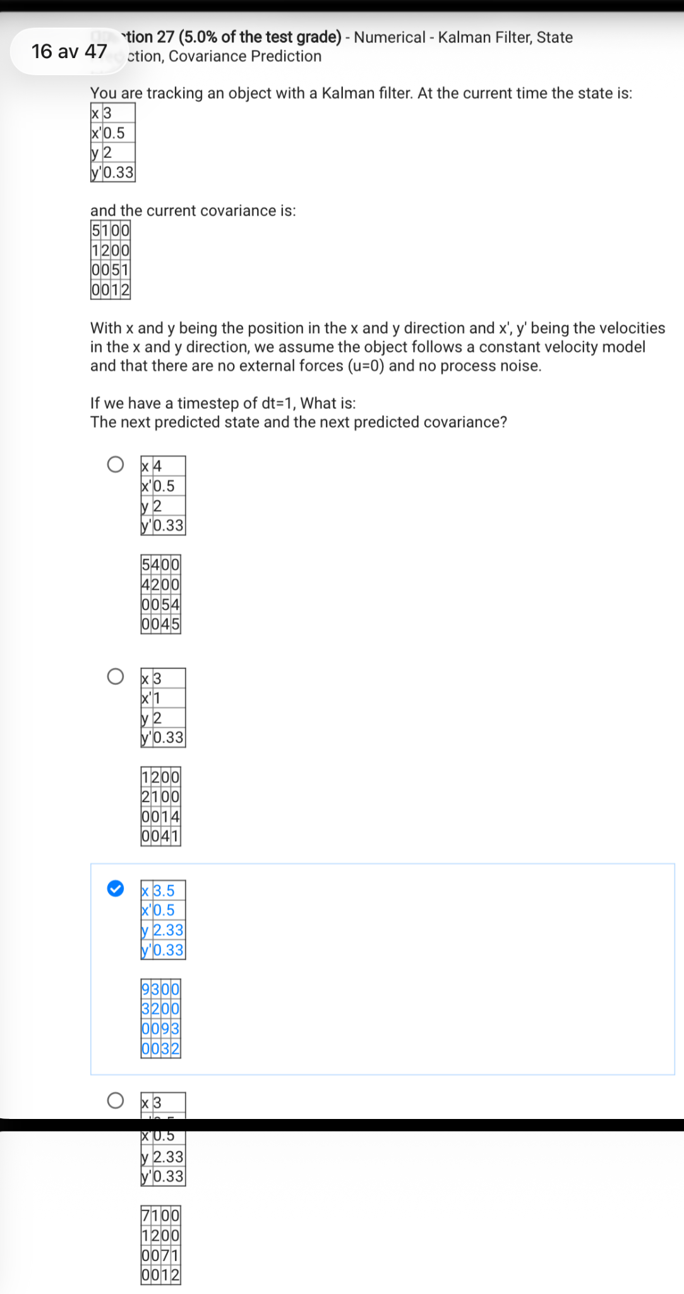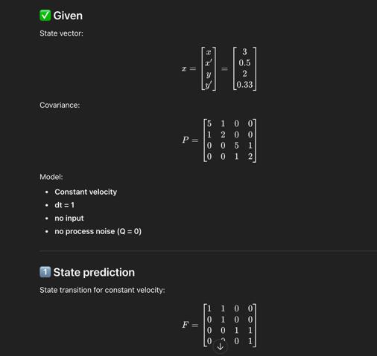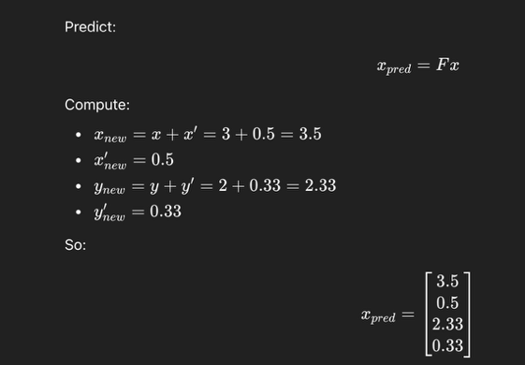 We use the constant speed and dt = 1 so we move 0.5 in x direction and 0.33 in the y direction

Stereo correspondence
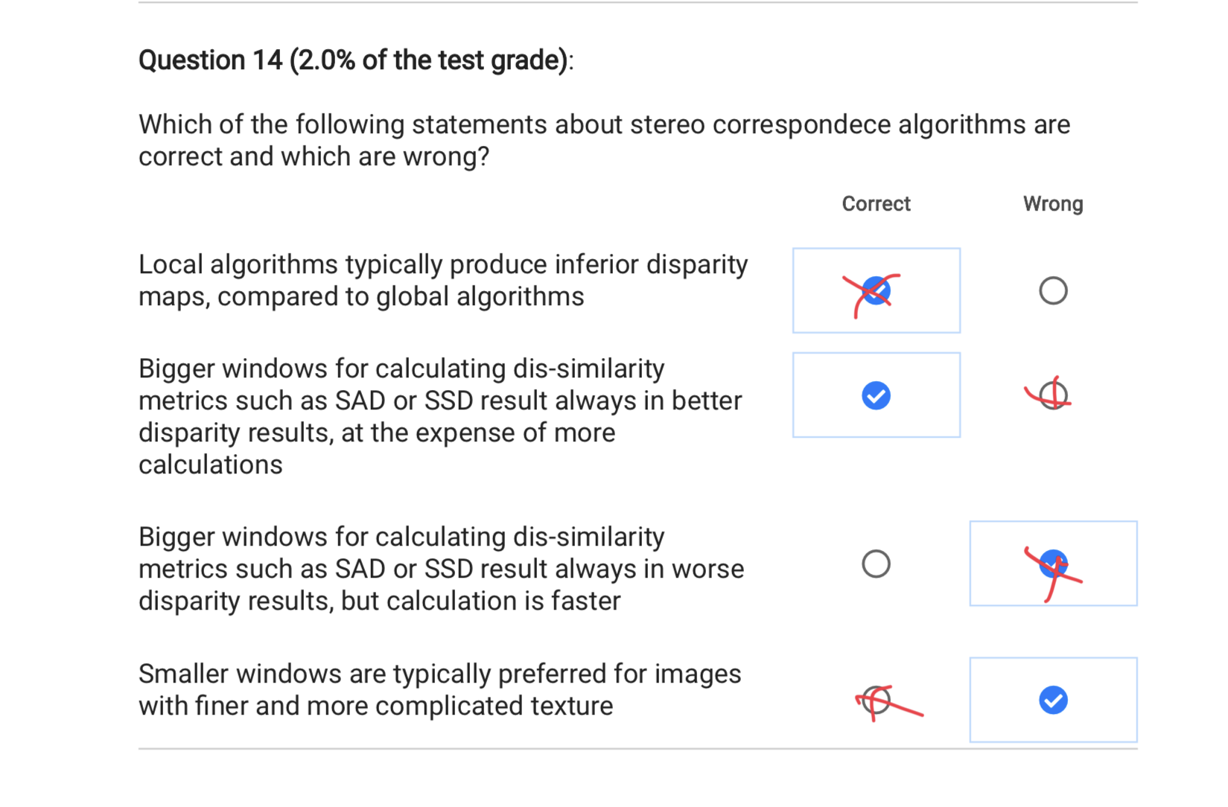

✅ Statement-by-statement verification

1) “Local algorithms typically produce inferior disparity maps, compared to global algorithms.”
➡ TRUE
Why:
Local = simple window matching → fails in textureless areas, depth edges.
Global = use smoothness constraints, optimize energy → usually more accurate.
This is exactly how stereo literature classifies them.
✔ This one IS correct.

2) “Bigger windows … always result in better disparity results, at the expense of more calculations.”
➡ FALSE
“Always better” is wrong — large windows help low-texture regions, but hurt edges / thin objects.
So the word always makes the statement false.

3) “Bigger windows … always result in worse disparity results, but calculation is faster.”
➡ FALSE
Two reasons:
- They do NOT always make disparity worse (sometimes they help).
- Bigger windows mean MORE computation, not faster.
So this statement is doubly wrong.

4) “Smaller windows are typically preferred for images with finer and more complicated texture.”
➡ TRUE
Small windows preserve details and do not oversmooth — exactly what you want for fine texture.
✔ This one IS correct.

✅ FINAL ANSWER
Correct statements:
- 1
- 4
Wrong statements:
- 2
- 3

If you'd like, I can also explain how SGBM internally balances the window size to avoid these trade-offs.

